TASK 04:- AGILE DEVELOPMENT MODEL

**PRODUCT NAME :- LAPTOP**

**1. Development**

* Firmware Development: Focus on the BIOS/UEFI, power management, and hardware-software integration (touchpads, keyboards, etc.).
* Software: Operating system optimization, device driver development, and compatibility with peripherals.
* Testing: Develop test cases for hardware compatibility, performance, and security.

**2. Design**

* PCB Layout:

Designing the motherboard, power delivery systems, and thermal management for heat dissipation.

* Industrial Design: Focus on aesthetics, ergonomics (keyboard layout, screen size), and material selection (aluminum, carbon fiber).
* Screen and Input Design: Optimizing for touchpads, keyboards, screen types (LCD, OLED), and their interactions with the software.

**3. Marketing**

* Launch Strategy: Define the laptop's target market (gaming, business, students), competitive positioning, and unique features.
* Marketing Campaigns: Develop key selling points around battery life, screen quality, portability, and hardware power.
* Distribution Channels: Plan online and offline sales strategies, including partnerships with major retailers and online platforms.

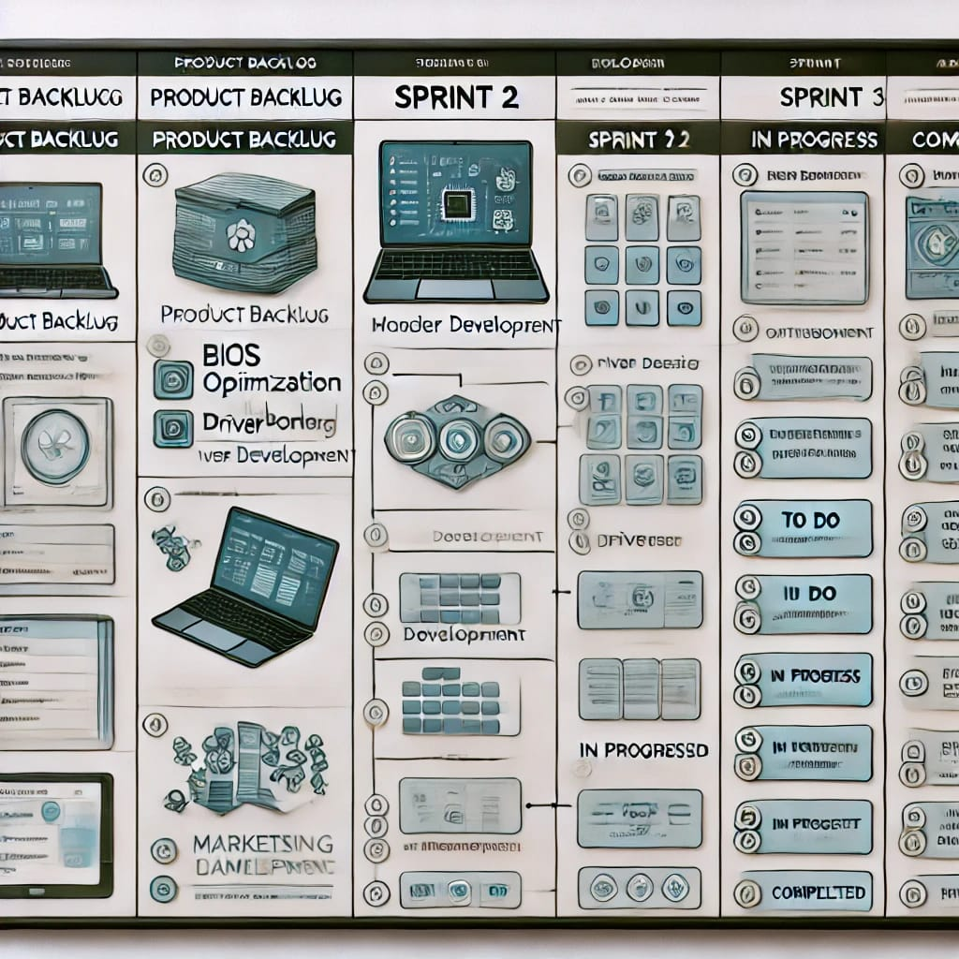

FLOW CHART FROM LUCID

